**INFORMATION ABOUT THE USE OF COOKIES**

Our website, [www.thefamilylearningapp.com](http://www.thefamilylearningapp.com), has been built using Wix.com, a leading cloud-based development platform, operated by Wix.com Inc. As a result our website does use cookies and other tracking technologies and these are used to distinguish you from other users of our website. Although we have no control over these they help to provide you with a good experience when you browse our website.

By continuing to browse the site, you are agreeing to the use of cookies and other tracking technologies.

A cookie is a small file of letters and numbers that are stored on your browser or the hard drive of your computer if you agree. Cookies contain information that is transferred to your computer's hard drive.

You can find more information about the individual cookies and other tracking technologies used on our website and the purposes for which they are used in the table below

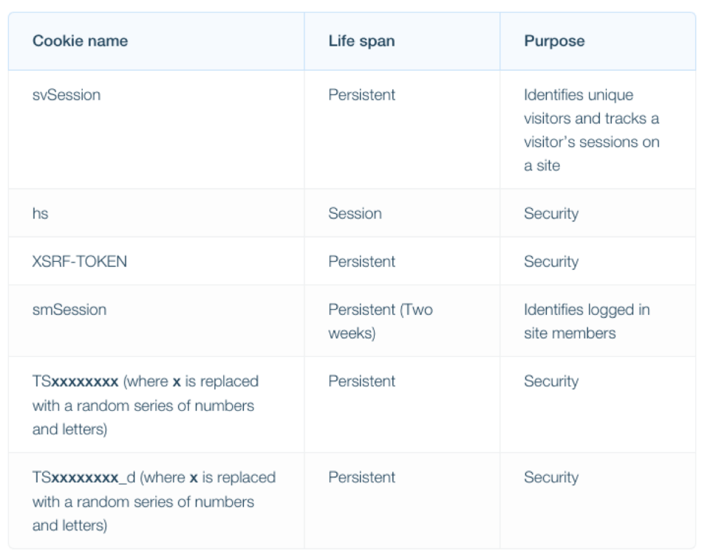

You block cookies and other tracking technologies by activating the setting on your browser that allows you to refuse the setting of all or some them. However, if you use your browser settings to block all cookies and other tracking technologies (including essential cookies) you may not be able to access all or parts of our site.

You can find out more about cookies, including how to see what cookies have been set and how to manage and delete them by visiting [www.allaboutcookies.org](http://www.allaboutcookies.org).